ServiceNow Flow Designer Automation
Project Documentation Format (Functional Specification Document)
1. Introduction
• Project Title: Streamlining IT Procurement: Automating Standard Laptop Orders with Flow Designer
• Team Size: 3
• Team Leader: MONIKA S
• Team Members: PREETHA S, RANJANI DEVI M

2. Project Overview
• Purpose: To automate standard laptop catalog requests, manager approval routing, CMDB hardware stock checks, and IT fulfillment task generation in ServiceNow using Flow Designer.
• Features: Provides a streamlined Service Catalog ordering interface, dynamic approval routing to direct managers, automated CMDB asset stock lookup, and auto-creation of SCTASK fulfillment tickets.

3. Architecture
• Platform: ServiceNow provides the platform, Service Catalog interface, Flow Designer execution engine, and CMDB asset repository.
• Workflow Automation: A Flow Designer workflow triggers upon catalog submission, evaluates requester profiles, routes approvals, checks hardware inventory, and creates fulfillment tasks.
• Data Tables: Utilizes Service Catalog requested items [sc_req_item], Catalog Tasks [sc_task], and Hardware Assets [alm_hardware].

4. Setup Instructions
• Prerequisites: Access to a ServiceNow Personal Developer Instance with permission to edit Service Catalog, Flow Designer, and CMDB tables.
• Installation: Import the laptop procurement catalog item, publish the Flow Designer workflow, configure manager approval steps, and map CMDB asset lookup actions.

5. Configuration Structure
• Catalog Item: Standard Business Laptop item configured in the Service Catalog with options for specifications and justification.
• Flow Trigger: Triggers when sc_req_item record is created for 'Standard Business Laptop'.
• Approval Step: Dynamic approval action routed to the requester's direct manager profile.
• Fulfillment Task: Automated SCTASK creation assigned to the IT Hardware Fulfillment group.

6. Running the Application
• Access the Instance: Log in to the ServiceNow instance and navigate to Service Catalog > Hardware > Standard Business Laptop.
• Submit & Test Order: Submit a laptop request as MONIKA S, PREETHA S, or RANJANI DEVI M and observe Flow Designer triggering automated approvals and fulfillment task creation.

7. Workflow / Security Documentation
• Trigger Type: Record Created (Service Catalog Request)
• Target Table: Requested Item [sc_req_item]
• Condition: Item is 'Standard Business Laptop'
• Advanced Logic: Uses Flow Designer action steps and script evaluation to verify CMDB stock levels before assigning tasks.

8. Authorization
• Role-Based Control: Uses User Criteria to ensure only authorized employees can request standard business laptops.
• Approval Restriction: Ensures requests require explicit direct manager sign-off prior to hardware provisioning.
• Fulfillment Assignment: Directs created SCTASK tickets specifically to the authorized IT fulfillment team.

9. User Interface
• ServiceNow Portal: Standard Service Portal catalog interface for submitting laptop orders.
• Flow Designer Workbench: Visual workflow builder showing execution steps, context logs, and step results.

10. Testing
• Functional Testing: Verified laptop request submissions, automated manager approval triggers, and SCTASK creation.
• Condition Testing: Validated workflow execution paths for both in-stock and out-of-stock laptop scenarios in CMDB.
• Script Testing: Tested script action steps for manager profile lookups and hardware serial number assignments.

11. Screenshots or Demo
Table Creation / Catalog Item – Standard Business Laptop
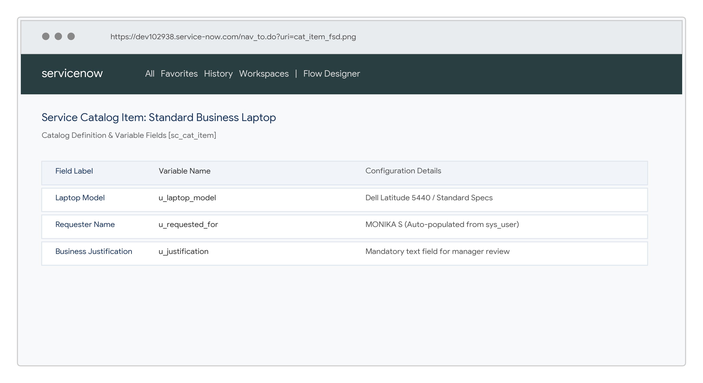
Laptop Order Requested Items List
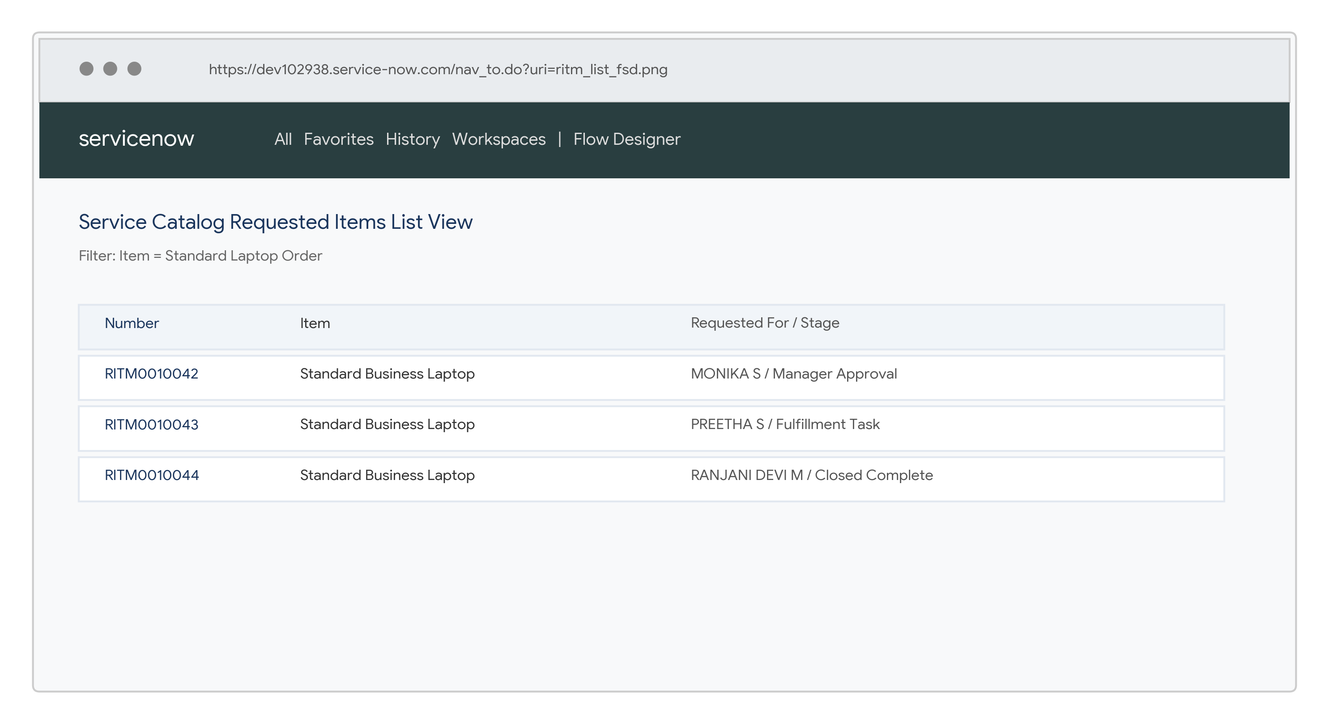
Flow Designer Configuration
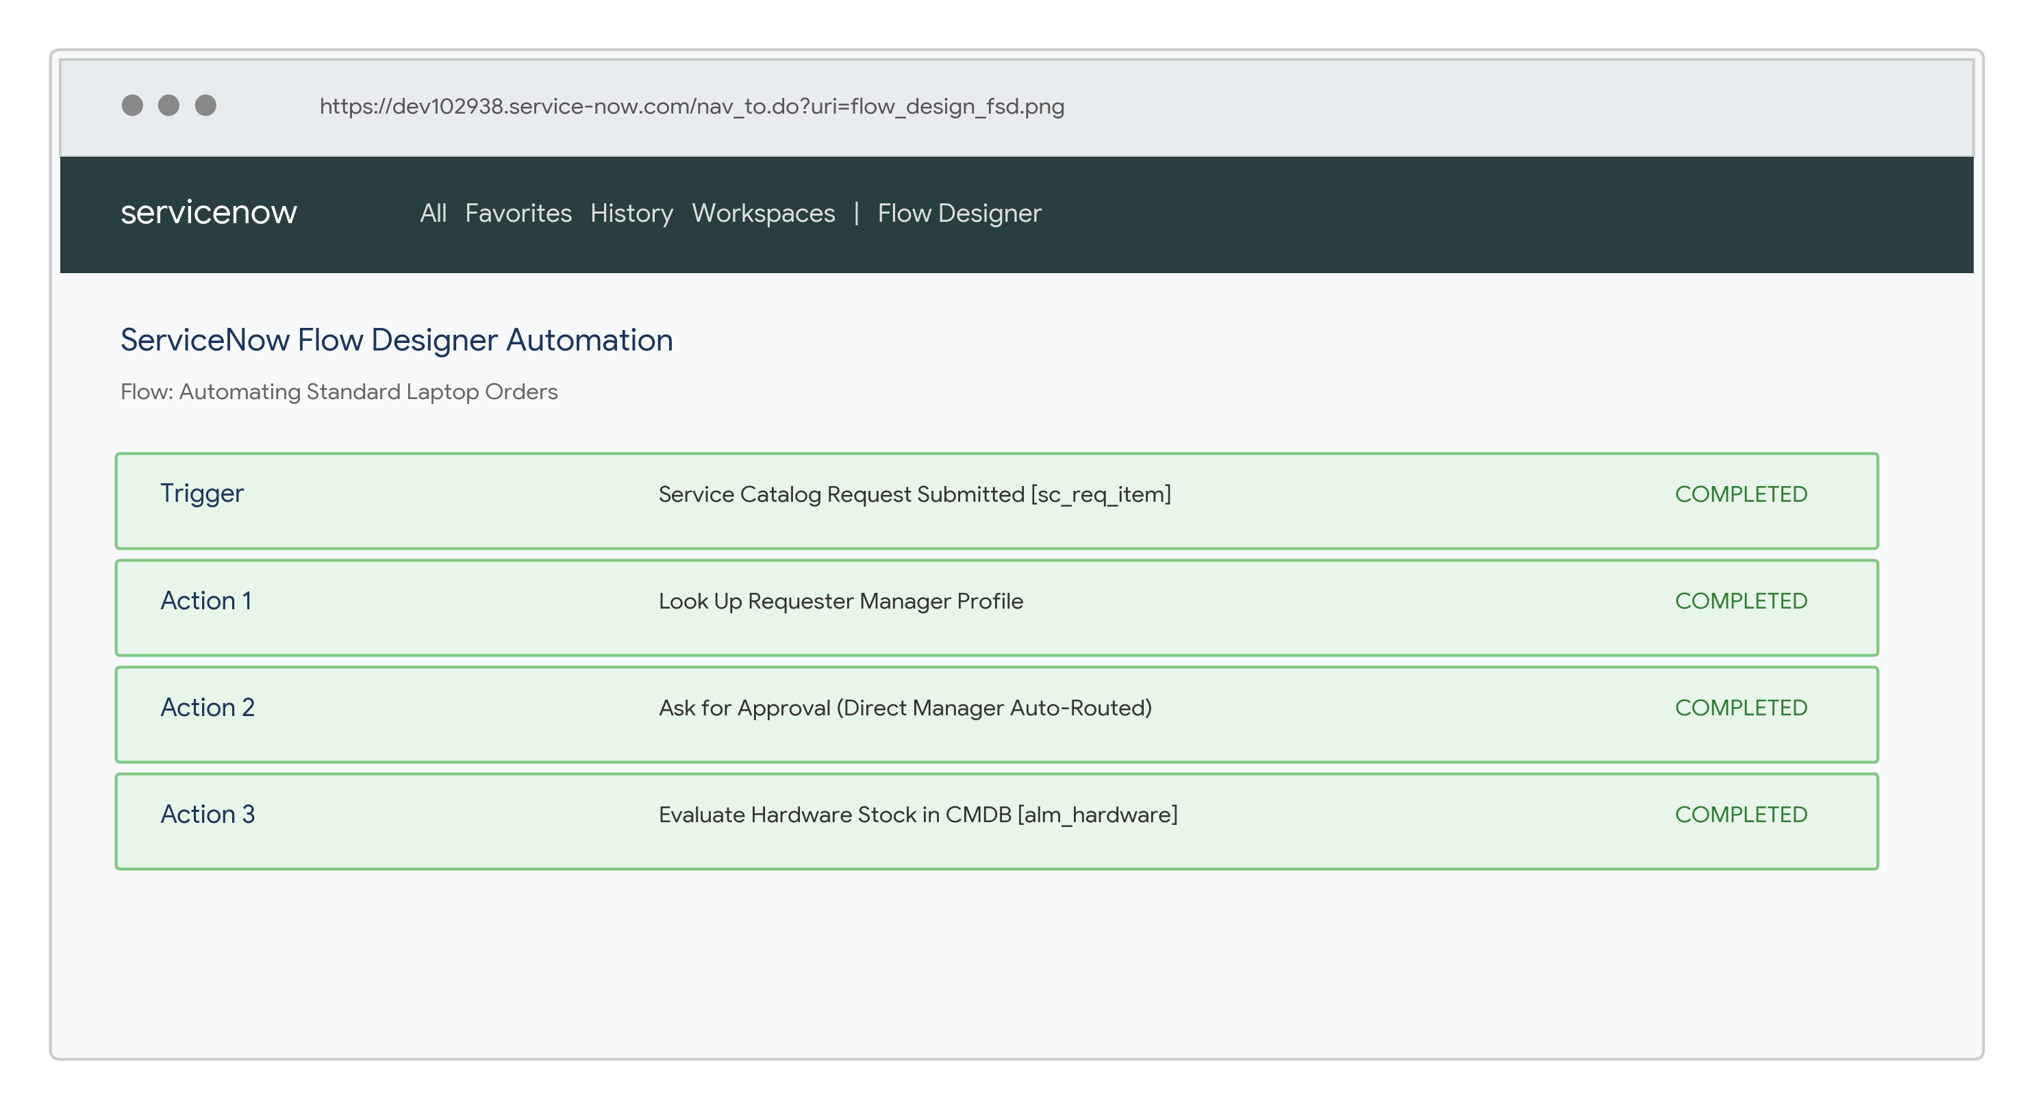
Approval Rule & Manager Routing
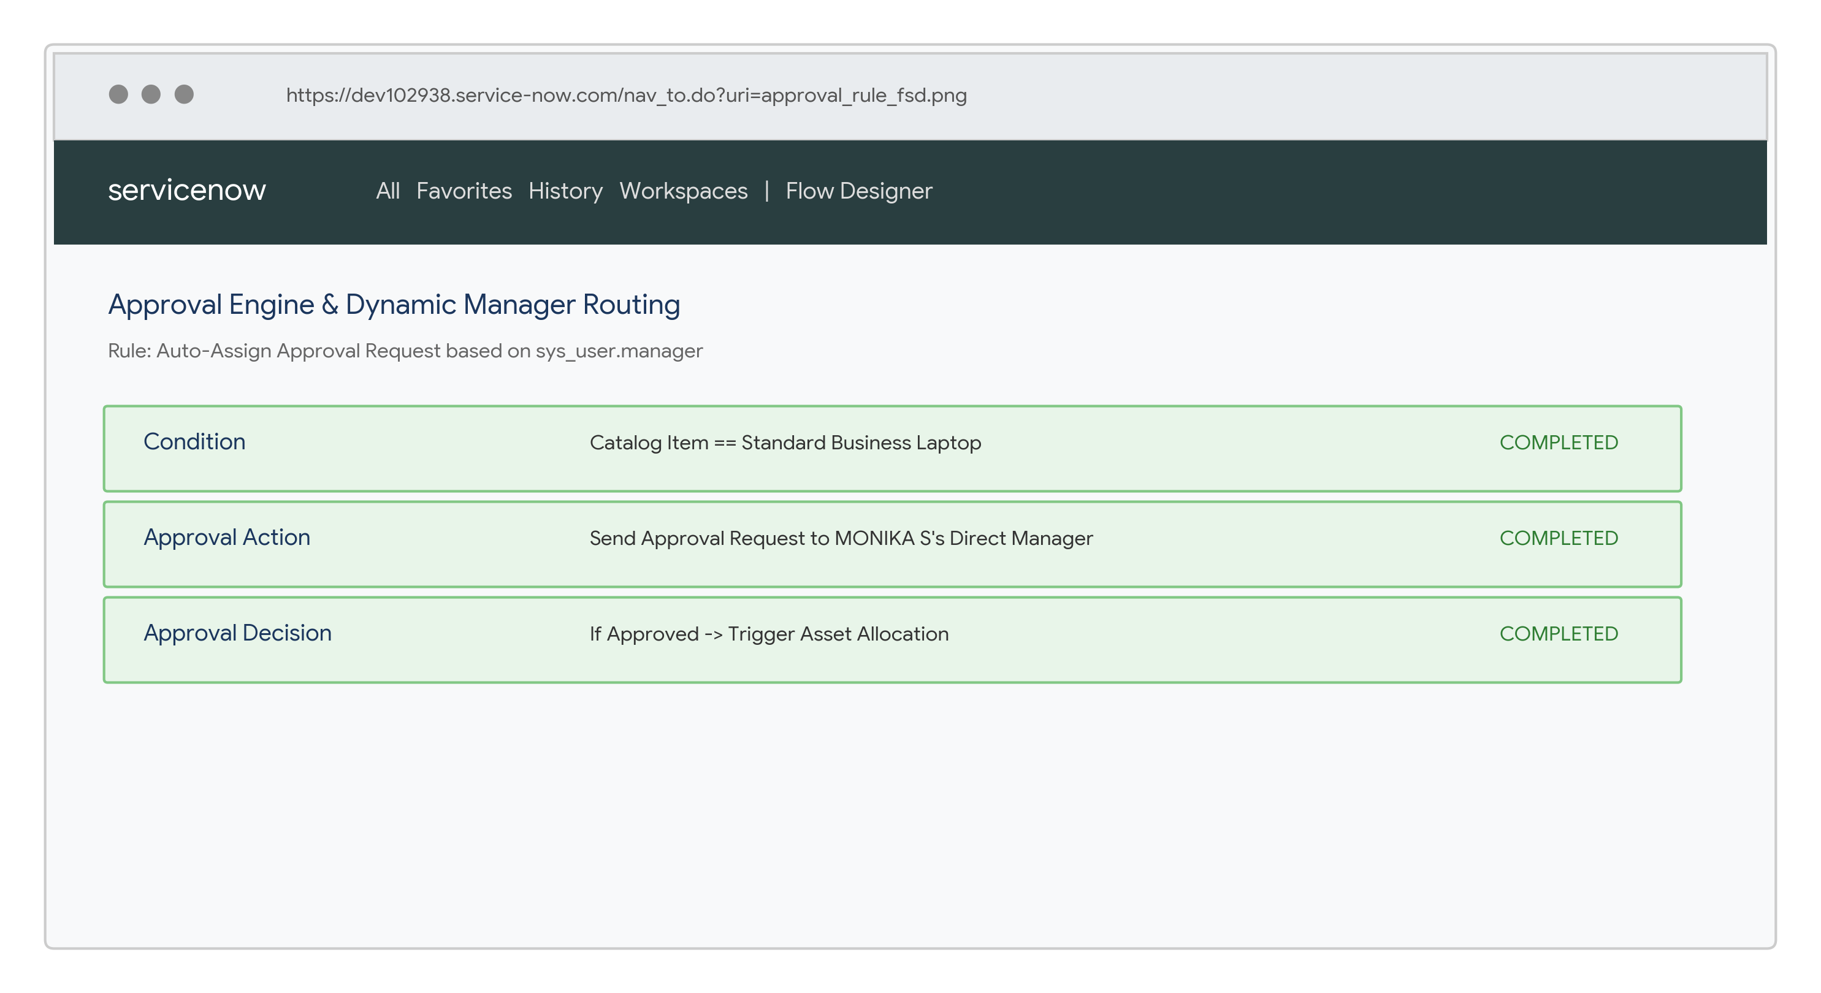
Advanced Flow Script & Stock Evaluation Step
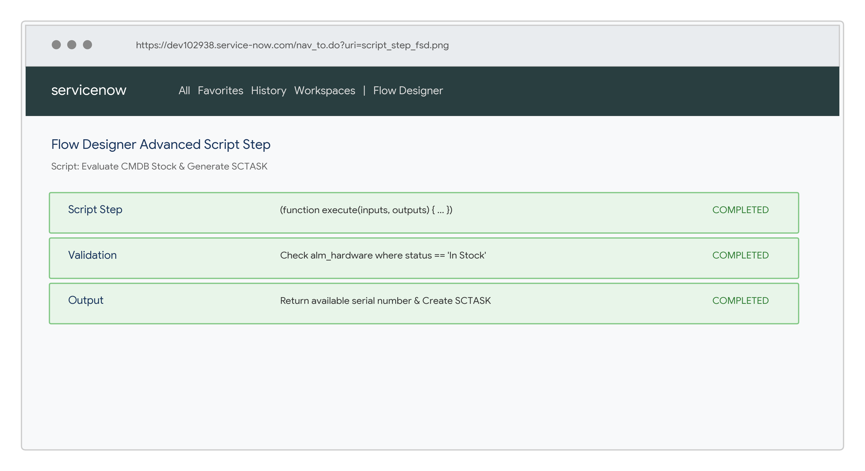
Final Access / Procurement Execution Result
• Demo Link: https://drive.google.com/file/d/10ZCQpUpZyN8Q8C6Leb9ulHTSry6-V0Mo/view?usp=drivesdk
12. Known Issues
• Configuration Dependency: Flow Designer execution depends on valid requester manager field populated in sys_user.
• Stock Dependency: If CMDB asset stock is zero, task creation routes to procurement back-order queue as intended.

13. Future Enhancements
• Multi-Item Procurement: Extend workflow to support bundled ordering of peripherals (monitors, docks, headsets).
• ERP Integration: Automate direct integration with enterprise ERP systems (SAP/Oracle) for automated vendor purchase orders.
• AI-Driven Asset Allocation: Use Predictive Intelligence to auto-assign inventory based on employee location and urgency.

Project Links
• GitHub Repository: https://github.com/Moni5467/Streamlining-IT-Procurement-Automating-Standard-Laptop-Orders-with-Flow-Designer

